



Support for Minors from Ukraine Aged 15+   
Who Are Not Students at a Secondary School in the Czech Republic

How to become a student at a secondary school?

What can I do next?

Where can I find support?

Prague, 21 October 2022

Support for Minors from Ukraine Aged 15+ Who Are Not Students at a Secondary School in the Czech Republic

How to become a student at a secondary school?

What can I do next?

Where can I find support?

This text, which was prepared by the Ministry of Education, Youth and Sports (MEYS), is intended for minor Ukrainians aged 15-18 years who have been granted temporary protection and who are not studying at a secondary school in spite of being at the age of secondary school students. This document provides information on where you can find free Czech language courses, how you can get involved in leisure time activities, who you can consult on matters related to life in the Czech Republic (CR), how studies at secondary schools take place and what you can do to get integrated into the secondary education process in the CR.

### I want to learn Czech, are there any free lessons?

If you are not older than 18 years and you do not attend any secondary school, then you can enrol in adaptation groups, which are funded by MEYS. Adaptation groups offer to teach Czech as a foreign language and provide the related preparation for starting studies at Czech schools. You can find the list of schools and organisations, which will be organising such groups, at [**https://www.msmt.cz/mladez/adaptacni-skupiny-pro-deti-cizince-migrujici-z-ukrajiny-zari**](https://www.msmt.cz/mladez/adaptacni-skupiny-pro-deti-cizince-migrujici-z-ukrajiny-zari). We recommend monitoring this website on an ongoing basis because new organisations will be continually added over time.

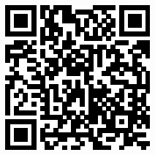Centres for Support of Integration of Foreigners, set up by the Ministry of the Interior, which are found in each region and the list of which is available at <https://www.integra-cnicentra.cz/>, can also help you get support for integration into life in the CR. These centres offer free social and legal counselling, organise cultural events and Czech language courses for both children and adults. For example, these centres can also help find organisations providing Czech language courses for free in the given location.

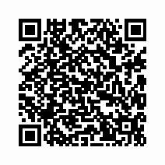If you have been granted temporary protection and you register at the Labour Office of the CR as a job candidate or a job seeker, you can apply for [**the provision of a Czech language course there, too**](https://www.uradprace.cz/web/cz/-/rekvalifik-14). You can obtain more detailed information from the closest contact office of the Labour Office of the CR; the list of such regional offices is available at <https://www.uradprace.cz/web/cz/krajske-pobocky>.

### Are there any online tools for learning the Czech language?

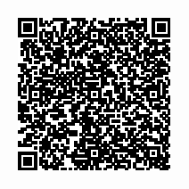The National Pedagogical Institute of the CR prepared and published a publication titled “First Aid in Czech – Special Teaching Material for Ukrainians”, which was specially developed for Czech language beginners this year. It will familiarise you with the Czech alphabet and pronunciation, and it will teach you to communicate in basic life situations. For convenient work with the text, most instructions in the text are provided with translation into Ukrainian. You can find the publication and the recordings at <https://cestina-pro-cizince.cz/trvaly-pobyt/a2/pripra-va-na-zkousku/prvni-pomoc-v-cestine-nahravky/>.

**You can also use other internet resources for self-learning:**

##### Czech language courses for foreigners, which were prepared by the Centre for Integration of Foreigners, available at <https://www.kurzycestinyprocizince.cz/cs/e-learning.html>;

##### A multimedia Czech language course, which was prepared by the Silesian University in Opava, available at <http://www.l-pack.eu/?page_id=402&lang=cz>;

##### Online textbook titled *Česky pomalu* (*Czech Step by Step*), available at <https://www.mozaika.eu/ucebnice-cestiny/>;

##### A mobile [application titled *Česky levou zadní (Czech Made Easy)*](https://app.ceskylevouzadni.cz/), which was prepared by the META organisation for the textbook titled *Levou zadní*;

##### Online course for the basics of the Czech language <https://redmonster.net.ua/uk/>;

##### Online exercises for the Czech language <https://www.umimecesky.cz/cviceni-cestina-pro-ukrajinsky-mluvici>.

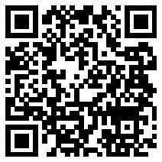If you need an online translator when self-learning or in other situations, we can recommend the following one: <https://lindat.cz/translation>.

### I Wish to Meet My Peers

#### This is an excellent idea for how to improve your knowledge of the Czech language and meet new friends. You will also have an opportunity to meet and establish contacts during various activities as part of the aforementioned adaptation groups, the purpose of which is also to familiarise you with the Czech environment, in addition to teaching the language. We also recommend visiting any leisure time activities near your place of residence; some organisations even have special websites for you, such as the Scout Association at [**https://www.skaut.cz/zvemedoskautu/**](https://www.skaut.cz/zvemedoskautu/)**,** or the Houses of Children and Youths, for example at [**https://ddmpraha.cz**](https://ddmpraha.cz), if you are in Prague.

### I Do Not Speak Czech Yet, and Therefore I need Someone to Interpret or Translation Information for Me When I Attend to My Matters

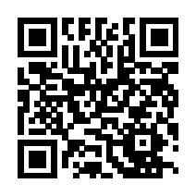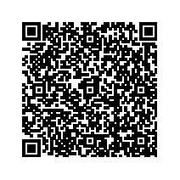If you need interpretation in common life situations, we recommend using the information line of Caritas, which provides anonymous and free-of-charge interpretation where only the price of the call, based on the operator’s rate, is paid: <https://www.charita.cz/jak-pomahame/doma/integrace-cizincu/infolinka-v-ukrajinstine/>. If necessary, they provide initial assistance and interpretation for unaccompanied children.

Organization for Aid to Refugees, visit <https://www.opu.cz/en/>, **the telephone line in Ukrainian is** **+420 228 229 942**. The integration centres will also mediate interpretation <https://www.integracnicentra.cz/>.

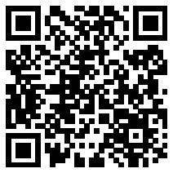

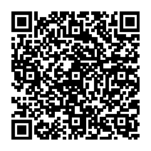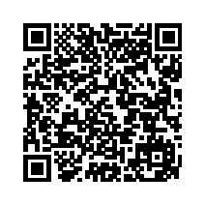You can find conveniently structured sheets with practical information for the most frequent situations regarding education of foreigners in the CR at <https://meta-ops.eu/prakticky-radce/praktichnij-poradnik/>. As concerns the translation of information, which you can use at school (such as the information for students at the beginning of the academic year, the translation of information for parents, etc.), we recommend first checking out the website at <https://cizinci.npi.cz/tlumoceni-a-preklady/> where some documents used frequently at schools have already been translated.

### Is there any list of all schools in the CR? Where can I find summary information on education in the CR?

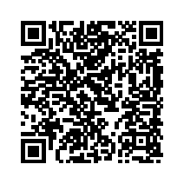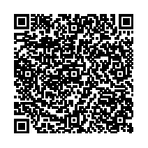There is a list of all secondary and tertiary vocational schools in Ukrainian, including the descriptions of the offered fields of education, on the website at [https://ukrajina.npi.cz/blog/  
vzdelavaci-nabidka-strednich-a-vyssich-odbornych-skol-pro-skolni-rok-20222023](https://ukrajina.npi.cz/blog/vzdelavaci-nabidka-strednich-a-vyssich-odbornych-skol-pro-skolni-rok-20222023). You can find summary information in Ukrainian on what to do in the area of school education when you arrive in the CR on the website at [https://www.edu.cz/ukrajina](https://www.edu.cz/ukrajina%20v záložce%20pro%20Ukrajince.) under the tab for Ukrainians.

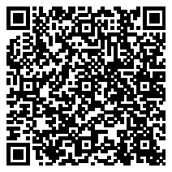You can get information in Ukrainian on the website at https://cizinci.npi.cz/tlumoceni-a-preklady/preklady-ss, which, for example, contains a guide titled “Education in the Czech Republic – Guide for Parents”. The guide can be fully used even by other persons interested in education. Another possible way of obtaining information on vocational education is the following publication at [https://www.cedefop.  
europa.eu/en/publications/8142#group-downloads](https://www.cedefop.europa.eu/en/publications/8142#group-downloads).

Information on the education system of the CR is available in English on Eurydice, a European information network, which provides information on education systems and education policy across Europe at [https://www.studyin.cz/soubory/clanky/  
0021_publications/Study-in-Profi-web-akt.-25.-3.-2021-.pdf](https://www.studyin.cz/soubory/clanky/0021_publications/Study-in-Profi-web-akt.-25.-3.-2021-.pdf), [https://eurydice.  
eacea.ec.europa.eu/national-education-systems/czech-republic/czech-republic](https://eurydice.eacea.ec.europa.eu/national-education-systems/czech-republic/czech-republic)**.**

### When can I start studying and what do I need for that?

You can start studying at any time during an academic year, provided that you have completed the compulsory school attendance period or obtained primary education before completing such a period and provided that the headmaster of the secondary school agrees with your admission and has capacity in his school for you. In the current academic year 2022/2023, you have an option of being admitted to the first grade (this is an exceptional option reserved for prospective students with temporary protection) or to a higher grade (this option is provided for in the Education Act for all prospective students).

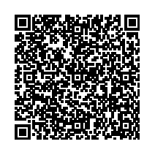So if you already studied at a secondary school in Ukraine and did not complete the studies, it is possible to continue your studies in the CR. If you have a school report, you will present it to the headmaster of a Czech secondary school; if you do not have it, you will write an affidavit, which will include specification of subjects that you studied). You can find a template of an affidavit on the web page at <https://meta-ops.eu/novinky/infobalicek-prijimaci-rizeni-rizeni-na-stredni-skoly-zapisovy-listek-a-2-kola/> or it is possible to use the reverse side of the secondary school education application form.

In order to be admitted to a Czech secondary school, you need not to present evidence of recognition of education or a certificate of recognition of equivalence of a document on completion of primary education, unless the education process ended before the compulsory school attendance period, which amounts to 9 years, was completed. You will document the completion of the compulsory school attendance period by presenting the relevant school reports or with an affidavit.

From a practical point of view, you need not worry if the headmaster puts to in a lower grade because in this way, you will have a longer time to become proficient in the Czech language and you will have better prospects of successfully completing the studies.

As concerns knowledge of the Czech language, you will need to prove this knowledge on a mandatory basis when enrolling for any study programme, which is completed by taking a General Certificate of Secondary Education (GCSE) exam (this applies to 4-year study programmes). The knowledge is verified in an interview, during which you must prove basic knowledge of the language necessary to study in the given study programme. An interview in the Czech language is not a part of the admission procedure for admission to study programmes completed by receiving a vocational diploma (this applies to 2- or 3-year study programmes).

### I was not admitted to a secondary school. What can I do?

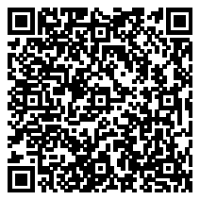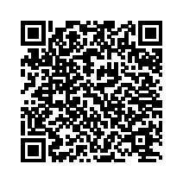Admitting a prospective student to a secondary school is within the authority of the headmaster. If the school was unable to accept you, try to enrol in another secondary school. We recommend choosing schools in smaller towns which are more likely to have free capacity than schools in large cities. You can also contact the regional education department in the region where you reside (you can find the contact information of the regional authorities at <https://www.statnisprava.cz/rstsp/ciselniky.nsf/i/d0049>), which monitors the free capacities of schools, or you can contact the aforementioned Information and Consultancy Centre of the Labour Office, see [https://www.  
uradprace.cz/informacni-a-poradenska-strediska-uradu-prace-cr](https://www.uradprace.cz/informacni-a-poradenska-strediska-uradu-prace-cr). It is also possible that you will have to commute to school. You pay the fare from your own pocket. The transport company operating in the given town or region will give you information on whether fare discounts are available for students.

### I am afraid of starting among new classmates and I worry that I will not be able to learn everything in time.

If you wish to study, do not be afraid to start! The reason is that as a student of a school, you have a significantly larger support from various resources, particularly for studying the Czech language, than a person who is outside the education system. On top of that, there is a specific support available to you at school, which is designed to prevent academic failure. And even if it happens that you need to repeat a grade due to your insufficient knowledge of the Czech language, it is possible to do so, provided that the headmaster approves it and that the school has free capacity in the given grade.

After you start studying at a secondary school, the headmaster may adjust the curriculum for you in this academic year for the necessary period of time to give you an opportunity to improve your knowledge of the Czech language. If you have been studying in the CR for a shorter period of time than 12 months, you are entitled to up to 200 hours of Czech language lessons for free at selected schools until June 2023. You will either commute to these schools or you can learn Czech online, too. The school where you will be a student will allow you to use their computer technology. Information on this opportunity will be given to you by the school, which you wish to enrol in. In every school, there is also an educational advisor at your disposal or there is a school psychologist or a specialist pedagogue in larger schools whose advice and assistance you can use if you have problems with learning, fitting in with classmates or if you have psychological or other problems. In some schools, there may also be Ukrainian assistants participating in the teaching process.

### I have multiple issues that I need to address. Can I ask someone for advice in person?

If you wish to get advice about the focus of your studies or about your subsequent job opportunities, you can take advantage of the services of the Information and Consultancy Centres of the Labour Offices of the CR (ICCs); their contact information is available on the website at <https://www.uradprace.cz/informacni-a-poradenska-strediska-uradu-prace-cr>. You need not register with the Labour Office in order to use this service.

The ICCs provide current information on secondary schools, tertiary vocational schools and universities across the CR, on the conditions and aspects of the admission procedure, on the requirements for individual professions, on the opportunities of graduates of individual study programmes for finding jobs, on the situation in the labour market in the regions and across the CR as well as on vocational retraining options.

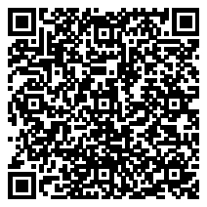The Centres for Support of Integration of Foreigners (<https://www.integracnicentra.cz/>) also provide free counselling regarding education or jobs. They also offer assistance in finding the suitable secondary school. If you are facing a problem with your arrival in the CR, take advantage of the **helpline in Ukrainian at +420 770 600 800**,the non-profit organisation People in Need or <https://www.clovekvtisni.cz/informatsiia-dlia-gromadian-ukrayini-8616gp>.

If you need to address a private problem or get advice, we recommend using the **social assistance line at +420 800 601 020**. It provides social counselling available to the callers **from Monday to Friday from 9:00 to 17:00** (Czech, Ukrainian, Russian, Roma and Hungarian languages) as well as crisis intervention (Ukrainian and Russian languages) **from** **Monday to Friday from 8:00 to 12:30 and from 16:00 to 21:00 as well as on Saturdays and Sundays from 12:30 to 17:00**.

### Can I interrupt my studies at a secondary school, return to Ukraine and then resume my studies in the CR?

You can interrupt your secondary school studies for a maximum of two years, during which you are guaranteed to have the option of resuming the given study programme. We would just like to point out that you will not be a student of a Czech school during the interruption of education. After the interruption of education ends, you may resume your studies in the grade, in which you interrupted your education or possibly, with the consent of the headmaster, in a higher grade, if you prove that you have the adequate knowledge. You need to apply for a permit to interrupt or end your studies with the headmaster in writing. All you need to do is to fill out and sign a notification form for end of education, which is available at <https://cizinci.npi.cz/tlumoceni-a-preklady/preklady-ss/>. One of the reasons why you should always notify the headmaster of interruption of your studies is to make sure you free up the capacity for other students.

### What does secondary school entrance exam look like?

#### For admission to study programmes with a GCSE exam, you need to take what is referred to as a uniform entrance exam in the Czech language and literature and mathematics, **https://prijimacky.cermat.cz/**. In 2023, the entrance exam for admission for the academic year 2023/2024 will take place on 13 and 14 April; the alternative dates are 10 and 11 May. The requirements and conditions for Ukrainian students may yet be specified. The exams from the past years are published at [**https://prijimacky.cermat.cz/menu/testova-zadani-k-procvicovani/testova-zada-ni-v-pdf**](https://prijimacky.cermat.cz/menu/testova-zadani-k-procvicovani/testova-zada-ni-v-pdf). In addition to that, some secondary schools organise a school-specific entrance exam; the related information is always available on the website of the given secondary school. A uniform entrance exam is not taken for admission to study programmes completed with a final exam (mostly a vocational diploma); the admission of a student to the school is within the authority of the headmaster.

### What exactly does a Czech GCSE exam look like?

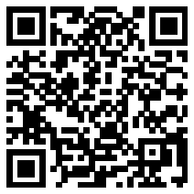A GCSE exam consists of a national part and a school-specific part. In the national part, a student takes two tests: a didactic test of the Czech language and literature, and then the student is free to choose between a didactic test of either a foreign language or mathematics; you can find the information and sample tests at https://maturita.cermat.cz/. In the school-specific part, the student takes an oral exam in the Czech language and literature and writes an essay; and if the student chooses a foreign language in the national part, then the student also takes an oral exam and writes an essay in this foreign language. Furthermore, the student takes 2 or 3 exams, depending on the school’s profile. Thus, in total, a student takes a GCSE exam in a minimum of four subjects. Foreigners are allowed extended time for the exams or they are allowed to use a translation dictionary.

### 

### What does the final exam look like and where do I take it?

The final exam is a vocational exam and is taken at the end of those study programmes, under which a student either acquires secondary education or secondary education with a vocational diploma. The information is available on the website at https://zkouska.cermat.cz/  
menu/zaverecna-zkouska.

A student will acquire secondary education by successfully completing a study programme with a duration of 1 year or 2 years in the form of full-time education. The final exam consists of practical tests in vocational subjects and oral theoretical tests in vocational subjects. After successfully passing the final exam, the student will receive a certificate of the final exam.

A student will acquire secondary education with a vocational diploma by successfully completing a study programme with a duration of 2 or 3 years in the form of full-time education or a study programme of reduced studies designed to obtain secondary education with a vocational certificate. The final exam consists of a written exam, a practical exam in vocational training and an oral exam. After successfully passing the final exam, the student will receive a certificate of the final exam and a vocational diploma. This means that an exam in the Czech language is not a part of any final exam.

### I have already completed a secondary school in Ukraine. What can I do next?

You can study at another secondary school or at a tertiary vocational school, taking advantage of various forms of studies: full-time education, correspondence courses, combined learning and distance learning. Until you reach the age of 26 years, your medical insurance will be covered by the government if you are a full-time student. If you have temporary protection, you do not need recognition of equivalence of your first General Certificate of Secondary Education.

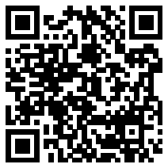You can also study at a university; see the website in English where you can find many pieces of advice and links <https://www.studyin.cz/>.

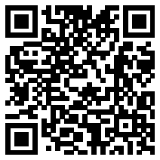If you wish to find a job, we recommend looking up the website of the Europass tool, <https://europa.eu/>[europass/uk](https://europa.eu/europass/uk), which is now available in Ukrainian, too. Europass offers you free services, which you can use to put together a CV, a motivational letter as well as an entire portfolio of documents on your skills. In this way, you can comprehensibly present and show your knowledge and skills when looking for a job, a temporary job or further education at home as well as abroad. After registering your profile with Europass, you will be offered many free services, which will enable you, for example, to search for and receive job offers and educational opportunities across Europe based on your interests. In your profile, you can also choose from the recommended suggested skills, save them and fill them in your CV and share your profile or parts thereof with employers or educational institutions.

### How is education acquired in Ukraine recognised in the CR?

You can find detailed information on how primary, secondary or tertiary vocational education that you acquired can be recognised in the CR on the website at <https://www.msmt.cz/vzdelavani/skolstvi-v-cr/nostrifikace-uznani-zahranicniho-zakladniho-stredniho-a> under the link with the Ukrainian flag.

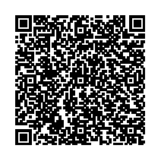You can find detailed information on recognition of your acquired university education at <https://www.msmt.cz/vzdelavani/vysoke-skolstvi/zvlastni-informace-pro-zadatele-o-nostrifikaci-z-ukrajiny>.

As a person who was granted temporary protection, you do not pay any administrative fee for acceptance of an application for recognition of education acquired at a foreign school.

### How are secondary schools from the CR recognised in the European Union?

In principle, acquired secondary education is recognised across the EU; there are differences in what each country requires as evidence of the education (a translation, recognition of equivalence or another exam). It also depends on the purpose, for which you need to prove your education. It depends on whether you need evidence of education in order to prove your qualifications, in which case the requirements are up to each employer, or whether you need the evidence for the purpose of further university studies. In the case of university studies, each university may have different requirements for admission.

Schools give each of their graduates the EUROPASS Certificate Supplement, which is attached to a GCSE or a vocational certificate and which describes the acquired education to provide information to a foreign employer.